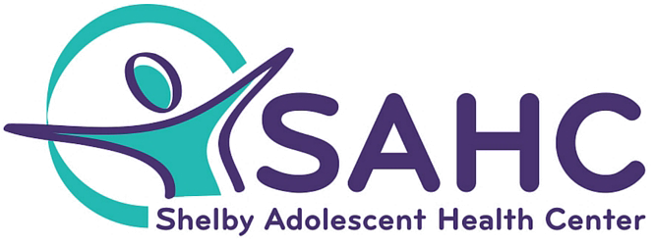

- The Shelby Adolescent Health Center works on a sliding fee scale that promotes access to care to ALL CLIENTS.

- The Sliding Fee Scale assures that no client is denied services based on their inability to pay.

- The discounts in the Sliding Fee Program are based on family size and income.

- The Shelby Adolescent Health Center accepts ALL insurances including Medicaid.

- If you don’t have health insurance and would like assistance with Medicaid Enrollment, just ask us, we can help you get enrolled!

