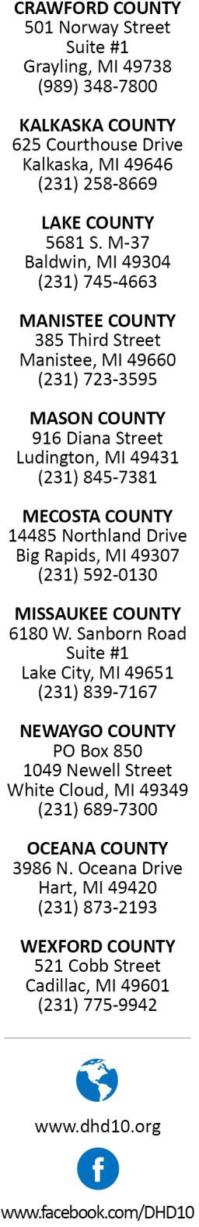

Congratulations!

You are proposing to build, convert or remodel a food establishment in Michigan.

The Food Law of 2000, as amended, requires plan review for new, converted, and remodeled food service establishments. The goal of plan review is to ensure the proposed menu, facilities, procedures and intended volume of foods to be served will meet food code requirements before construction or remodeling begins. Plan review involves submitting plans and other related materials, receiving feedback, then providing additional information or adjusting plans as necessary. For an accurate and timely review, all requested documents must be submitted as a typed-up and printed packet with floor plans as follows:

All floor plans need to be on graph paper at least 25”x30” (the size for a large/presentation sticky note pad).
- Floor plans with equipment numbered, to match.
- A corresponding numbered equipment list, to match.
- Numbered equipment spec sheet.

Please submit all documentation compiled into a single package, along with the appropriate fee to DHD #10 to the following address:

DHD #10 Plan Review
Mason County
916 Diana Street
Ludington, MI 49431

Contact the Mason county office at 231-845-7381 to pay the plan review fee.

